KILIFI KIDS KAITI- FINAL MBUINI/KAIA/KILALA MONITORING & SUPPORT ACTIVITY REPORT FEBRUARY 2018
Region | Activity Dates | Sites | Persons involved
Makueni County | 24th,25th and 26th January 2018 | Kaiti Sub County  Mbuini, Kaia and Kilala CUs | Sam Kanga: Senior project manager Medic Mobile  Susan Maigua: Project manager Medic Mobile  Elijah Gichanga: Tech lead  Christine Were: Project manager Medic Mobile  Alice Waguthi : Kilifi Kids Executive director  Jacinta Ngumbi: Kilifi Kids field manager  Josephine Julius:Sub County Community Strategy Focal Person
- Background to the Activity;

Monitoring Objectives

Prior to this activity, the second monitoring and evaluation for Kilifi Kids Makueni project took place on in February 2017. The process allowed all partners to assess the impact of all activities in the community units, determine how things could be done better and to show what action different stakeholders are taking. This should translate into a more effective and transparent way of working.

The final Monitoring activity carried out in January 2018 included discussions of project close out by February 2018 and handing over of the Makueni Mhealth project sites (Kilala, Kaia and Mbuini) by Kilifi Kids to the Director of Health Makueni County.

Medic Mobile and Kilifi Kids team travelled to Makueni County where we met with the MoH stakeholders who have been involved in the project.

M&S Tools and Approaches applied

Participatory methods – All stakeholders were actively involved in discussions and decision-making.
There was a sense of ownership of project performance results and recommendations.
This gave us an actual understanding of conditions and changes that might be experienced in the future.

Refresher and Q&A sessions- This was done during the CHVs sessions

Rapid appraisal methods - We got views from active CHVs and inactive CHVs, Sub county facility beneficiaries and stakeholders.

- Progress

The first meeting was held on 22nd January, 2018, where we met with the Kaiti Sub County Health Management Committee. - (Dr. Makau SCMOHH TEAMS, Vincent Maingi SCPHO, Josephine Julius SCCSFP, John Kangwele SCASCO/SCTLC, Justus Muinde SCDSC, Stephen Munywoki SCMLT, Doreen Muendo SCRHC, Arnold Musyimi SCMC, Lucy Wambua SCHAO)

After introductions were done, Medic Mobile presented how the Medic Mobile platform works within the ANC and Immunization workflows.
Kilifi Kids elaborated more on the project performance and progress and impact it has had on the Kaiti Sub County CUs as well as the daily work the CHVs have been doing, project sustainability and the project close out checklist

On 23rd January, 2018, we met with the Makueni County Health Director. - (Dr. Ndolo). Similar to the previous day, Medic Mobile made a presentation showcasing how:
-The Medic Mobile platform works within the ANC and Immunization workflows.
-The Kilifi Kids Makueni dashboard

Kilifi Kids led the discussions with the Director of Health highlighting the following areas:
-Project performance and progress
-Project sustainability through Budget for Airtime, CHV Allowance, Capacity Building CHVs, RCC Support and IGA initiatives
-Project close-out checklist

On 24th January, 2018, the team met with the CHVs from Mbuini CU. The meeting was held at Mbuini Dispensary. Members present included;
- Dr. Makau: SCMOHH TEAMS
- Stephen :Mbuini Dispensary Nurse/CHEW
- Stephen :Mbuini Dispensary PHO/CHEW
- Mbuini Community Health Volunteers

During the meeting, a refresher training led by MM was conducted where various reporting gaps were identified and addressed. Dr. Makau had an extensive discussion with the CHVs encouraging them to continue utilizing the platform to ensure that the community does not miss out on the needed services. The CHVs were keen to point out the need to have an ambulance and a laboratory allocated at the dispensary. This would help lessen the referrals made to the sub-county HF and encourage locals to use the available public health facility.
It was noted that the Mbuini CHVs had begun a vibrant table-banking initiative where the members are able to access soft-loans and acquire soft skills like soap making. The CHVs requested that the sub-county should consider extending tenders to them for the various products needed e.g. soap in support of their initiatives.
KK Director got an opportunity to highlight the most active and least active CHVs based on the data submitted. The best performing CHVs as well as the facility CHEWs were adorned with gifts and tokens of appreciation for their dedication and commitment.

On 25th January, 2018 the team met with the CHVs from Kaia CU. The meeting was held at Kaia Dispensary. Members present included;
- Dr. Makau: SCMOHH TEAMS
- Joel Mbiti: Kaia Dispensary Nurse/CHEW
- Kaia Community Health Volunteers
Similar to Mbuini meeting, a refresher training was conducted led by MM with the support of KK Field Officer. Various system challenges were raised and addressed. It was noted that the facility did not have a danger sign reported and this was confirmed by the facility nurse on site. The best performing CHVs were handed various gifts which served as a motivation for their dedication. Notably, the least expected CHVs were identified as the most active in reports submission.

A similar meeting was held on 26th January, 2018 at Kilala CU. The meeting was held at Kilala Model Dispensary. Members present included;
Dr. Ndolo: County Director for Health
Isaac Mwololo: Kilala Dispensary Nurse/CHEW
Kilala Community Health Volunteers

After a brief introductions in each of the sites, participating CHVs shared their expectations.
These included;
Replacement of broken Tsims and phones, New programmes for the year 2018 and current news from KK, Refresher on forgotten information, Replacement of inactive CHVs, CHVs wanted to know why Tsims were collected, All CHV challenges to be heard.

A refresher session on MCH and the Medic Mobile app System was conducted. Participants broke into group sessions to discuss use, benefits, challenges, solutions and way forward. Below is a summary of the FGD discussions from all the three sites.

Benefits of using the mhealth system:
- The CHVs find the Tsim App straightforward and easy to use.
- Use of the Tsim App through the phone makes CHVs work efficient because it is less time consuming and there is less paperwork trail e.g. no carrying of bulky writing materials.
- CHVs feel more effective because they have been empowered to use a digital tool for CHV operations; apart from reminders they use the phones to call and follow up on patients on Referral as well as communicate with each other.
- Referral of danger signs (high risk pregnancies is much faster.
- The OFF form allows the CHVs to disable notifications of women and children lost to follow up.
- CHVs feel more effective because mothers have gained more confidence in them through this, ANC and IMMR is now taken more seriously by the Kaia.
- CHVs feel more visible and their work recognized within the community because of use of the TsimApp
- Use of phones enhances general communication for the CHVs with HH, Doctors and Nurses.
- The phones came with a solar charging unit which they use also as a source of light.
- Regular phone use made the CHVs phone experts

Use of mHealth enhances the strength of the CHVs as it gives them an opportunity to share more on their daily operations, through their bi weekly meetings. They see a future where through this initiative, they can also get tenders from the MoH through their registered Self Help groups and table banking initiatives in which all the CHVs are active and have elected officials (chairman, vice chairs and a secretary)
They were advised by Kilifi Kids to continue with their income generating activities and through this showcase their commitment to overall development issues in Kaiti Sub County. This kind of socio economic activities work will motivate them to be more accountable to each other and the MoH and participate in decisions governing health issues in Kaiti locality and ultimately Makueni County.
Ultimate outcome is that more mothers go to the facilities for ANC and for delivery, More children have improved health because of continuous immunization follow up by notification reminders

Nurse Workflow
We had an extended discussion with the Kilifi Kids team, and the nurse about the nurse workflow
- The nurses do not have challenges while sending the confirmation reports as the MM IDs are being recorded in the MCH booklets
- They are still confirming the visits after examining the pregnant woman or injecting the children
These are the advantages of the nurse workflow especially because now they were provided with laptops
- They are able to better monitor the defaulters through viewing the Webapp
- They can send messages to the CHVs through the Webapp
Some challenges expressed included women choosing to go to other facilities for ANCV and delivery therefore lost to follow up.
The CHEWs also see this as a challenge. The CHEWs also noted that the notifications to follow up with defaulters usually come in on Sundays only.

- Challenges and Way forward

Challenges | Recommendations
MM System Challenges  - CHVs shared that notifications come to their phones, during odd hours like 2am and 3am  - Nurse workflow challenges e.g. Sometimes the CHVs get numerous notifications to follow up with mothers for defaulting yet when they go to follow up they find the mothers had already gone to the clinic yet it is the nurses who have not sent ANCV and IMMV confirmations | - Medic mobile to check on this and see if they can be reset and follow up with Jacinta to check on improvement.  - Jacinta to check with Nurses regularly to ensure that ANCV and IMMV forms are sent regularly and in time.
Technical challenges  - Sometimes the phones fall and the Simcards move therefore phones do not register both Safaricom or Tsim  - Phone battery degradation over time  - Broken Tsims impedes submission of digital reports  - Loosing phones impedes submission of digital reports | - Jacinta to check with the CHVs on a regular basis to ensure all phones that have Tsims are working well  - Faulty phone and extremely less powerful batteries to be replaced (for the ones that warranty still exists) by KK in coordination with the Jacinta through their IGA schemes
Social-Economic challenges  - The CHVs who had lost their phones have not been able to purchase new ones  - Now that the CHVs have mobile phones that help facilitate their work, they are viewed as more professional, however they are perceived to be better off financially by the families they visit who expect to get something in return other than advice. For example a mother would ask for bus fare to go to the clinic for ANC or to take the children for IMM. | MOH will support an income-generating project that CHVs can borrow money to replace phones. KK to follow up, make sure MOH provides Motor Bikes as promised.  - Replacement of lost phones by the CHVs themselves was recommended by KK as one of the ways to enhance accountability of ownership  - It was suggested that at a later forum, there would a discussion about proposal writing for income generating initiatives that could be presented to “The Rotary and KK” to request for funding support.  - It was also agreed that CHVS can be active in advocating for allowances and other CHV needs through petitioning and they can use the medic mobile tool to showcase their work to MOH.  - It was mentioned that MoH need to create more awareness about the volunteer role of the CHV to the community in order to manage the community’s expectations.  - General awareness creation about the importance of attending ANC and Immunization as a direct benefit to the end user themselves.
- Some mothers are stubborn and don't go for ANCV on time even though CHV reminds them. Same for the children they are to take for IMMV  - Some mothers don't trust the young nurses at the facility and therefore don't go for ANCV  - Lack of lab facilities at Mbuini dispensary de motivates mothers to do to their 1st ANCV within the 1st trimester. They go to other facilities. | - General awareness creation about the importance of attending ANC and Immunization as a direct benefit to the end user themselves.  - It was suggested that Kaiti sub county health facility need to assist with mobile lab services at least twice a week.

The CHVs agreed that these were the challenges they have been experiencing and they were enthusiastic about the recommended solutions hopeful that MoH will adopt the digital platform. The Kilifi Kids representative; Alice emphasised that the MoH need to discuss on each stakeholder’s role in implementing the suggested solutions.
Dr Makau attended the Mbuini and Kaia FGDs while Dr Ndolo attended the Kilala FGD.

Kilifi Kids conducted a ranking of CHV performance exercise in order of best performing and least performing ones. The best performing CHVs were given awards and celebrated by the rest of the CHVs while the least performing were urged to catch up with their colleagues and register as many women and children as they could for follow up.

Kilifi Kids are to expound further all the handover costs to MoH for a better understanding of what is required for the system to be running after closeout phase.

Medic Mobile is to be on standby for direction from MoH on a way forward because the project is coming to a closeout.

e) pictorial
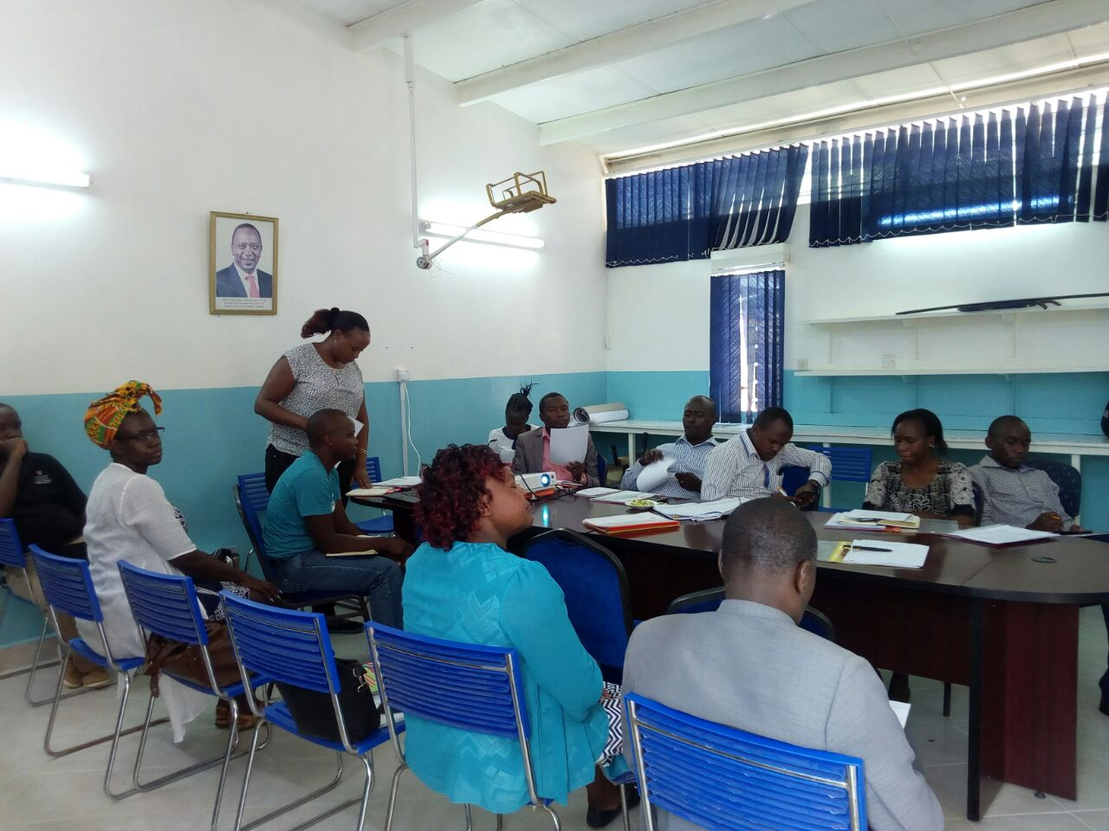
Alice from Kilifi Kids making her presentation on project successes and close out to the County Health committee at Makueni Referral Hospital

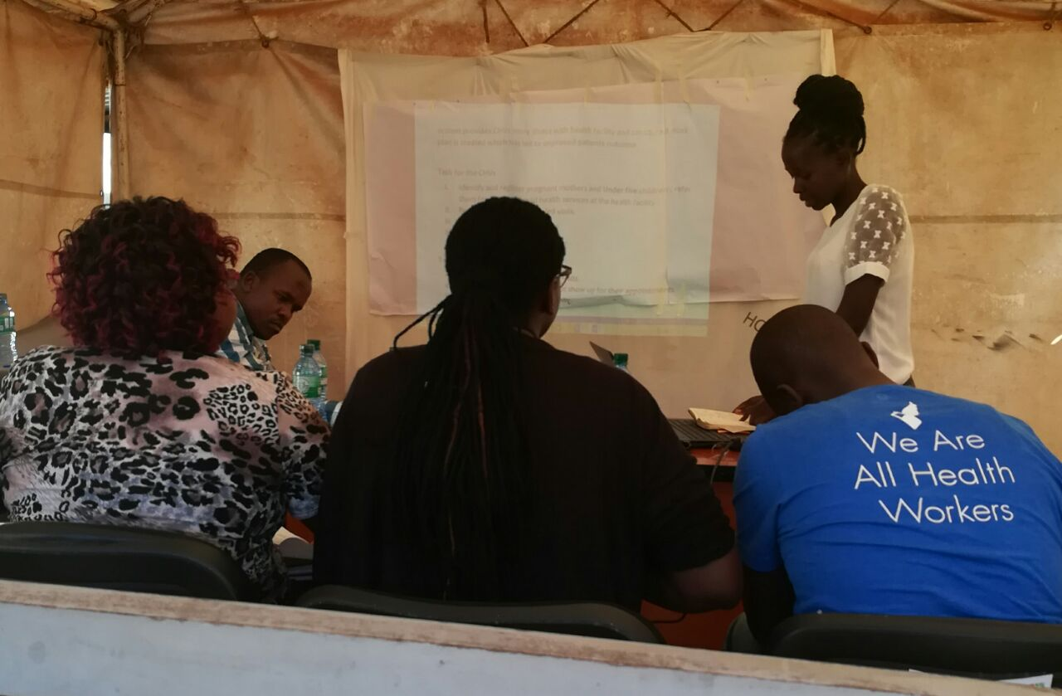
Jacinta Ngumbi Kilifi Kids Field Officer presenting on workflows to the Sub county Health Committee at Kaiti health facility

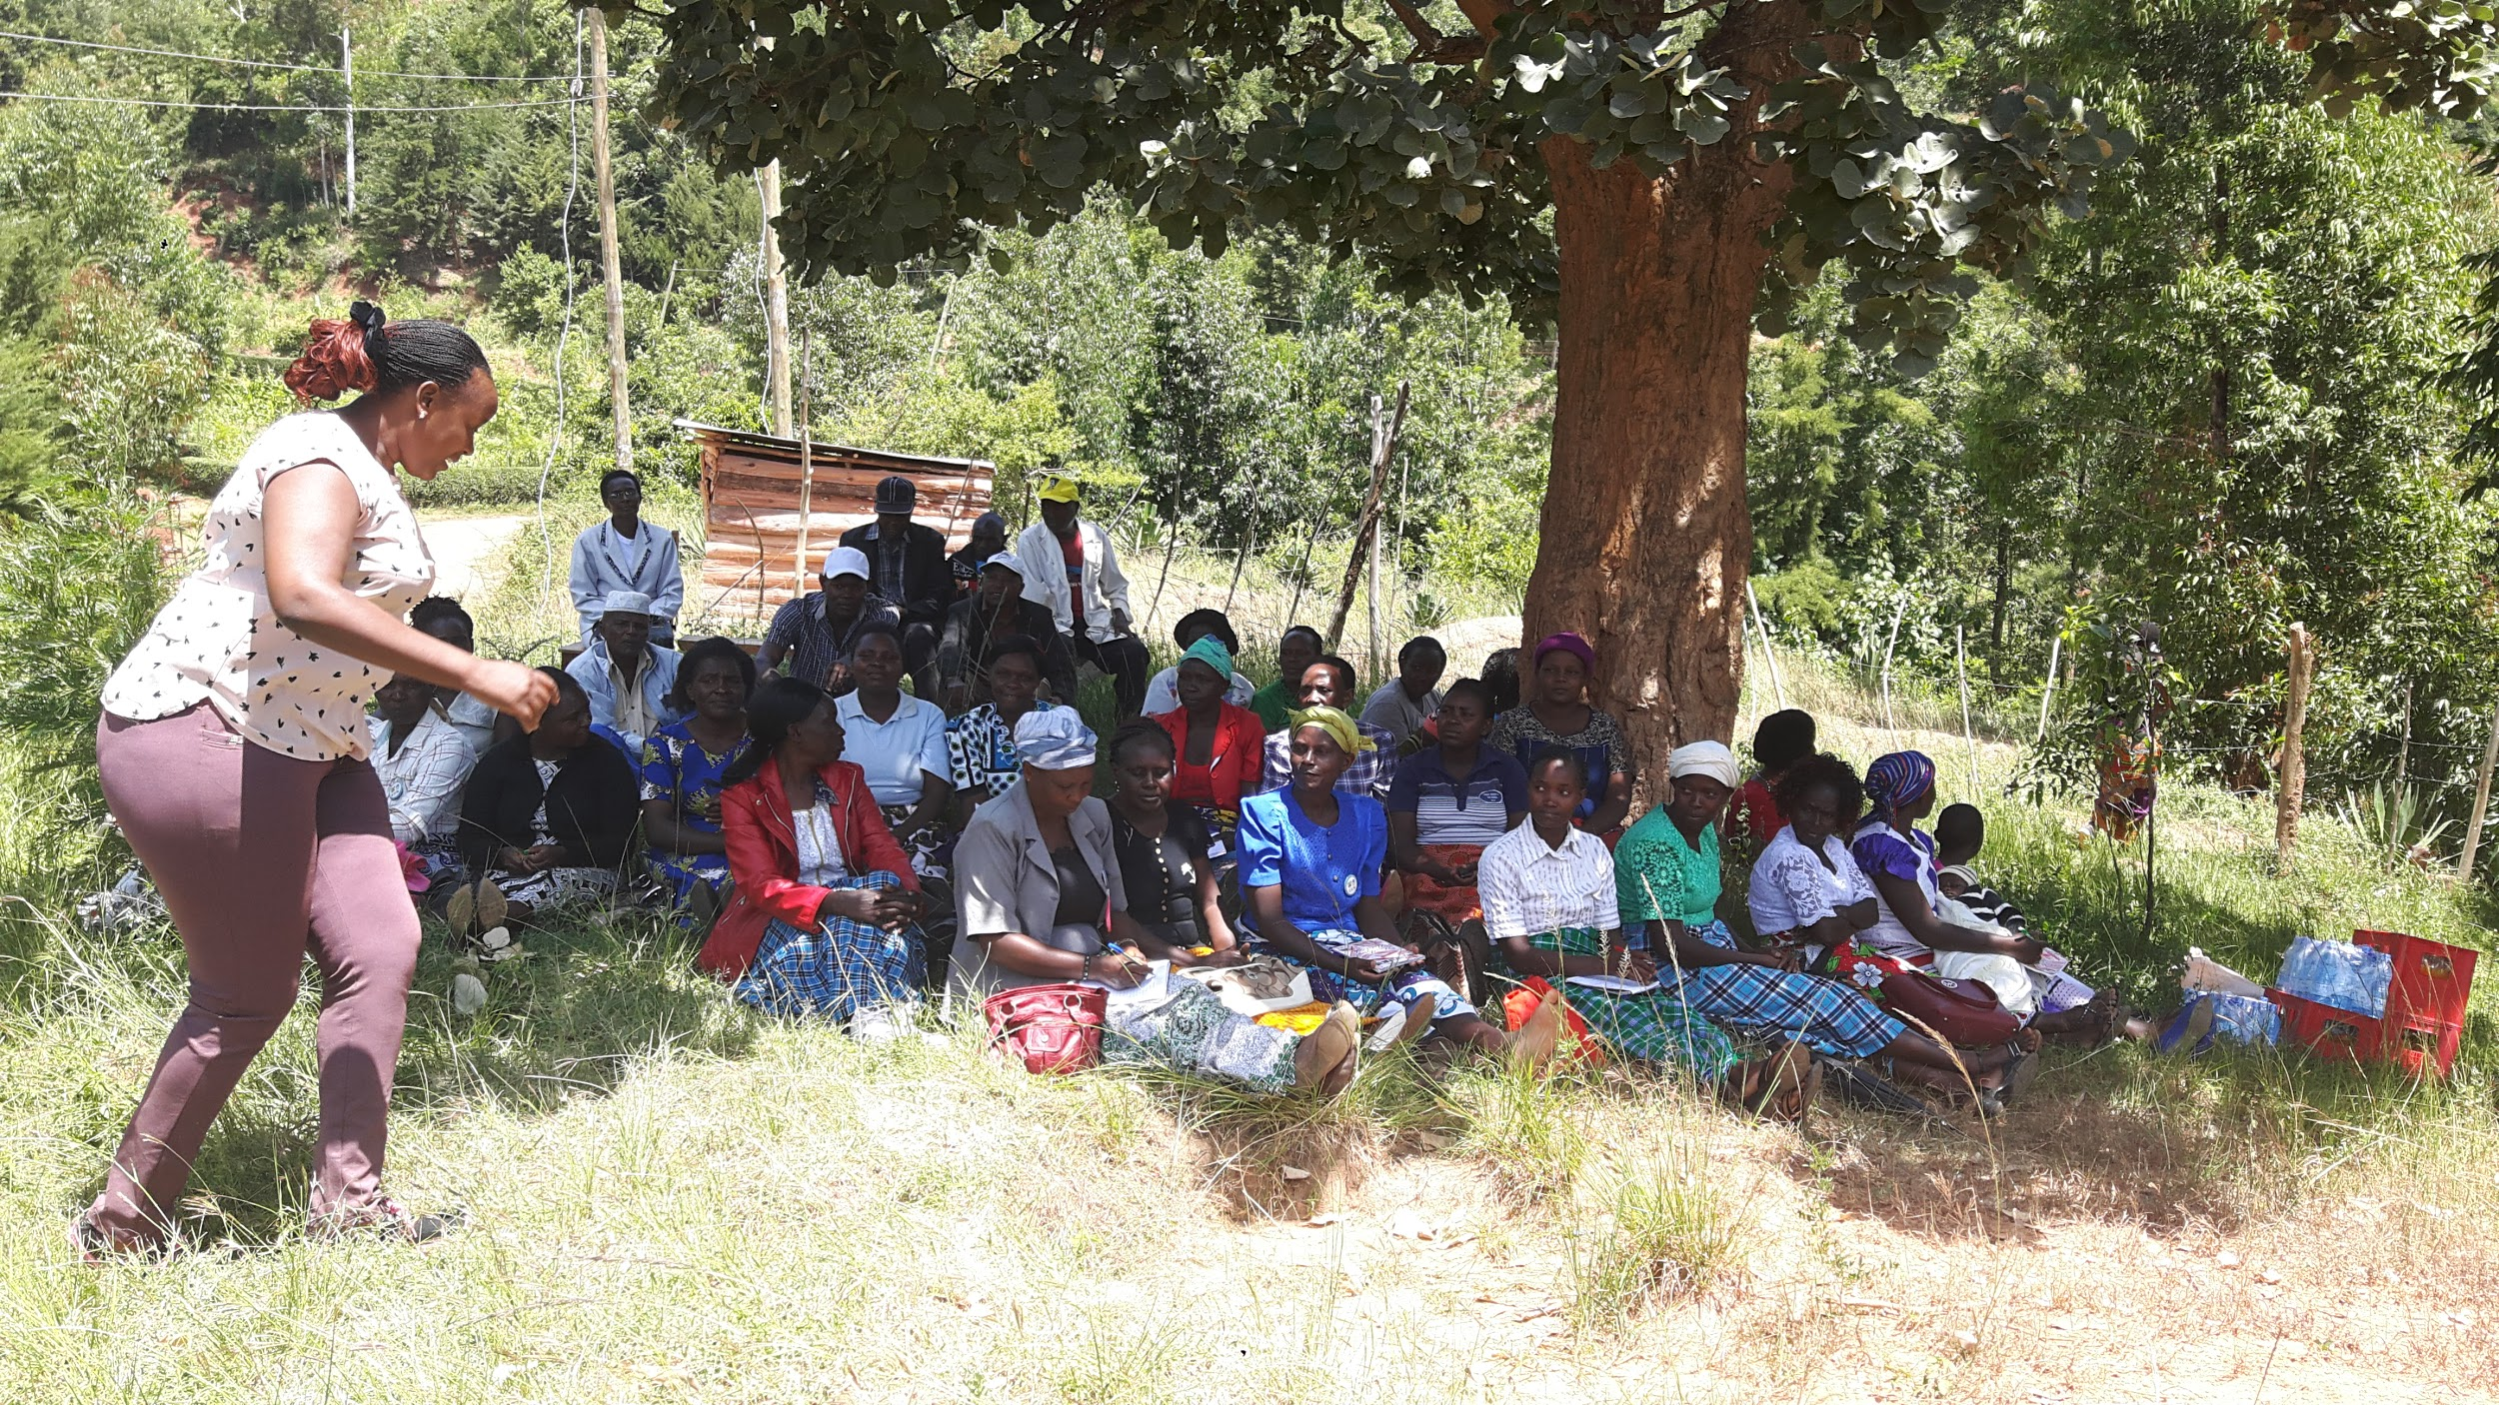
Alice Kinyua of Kilifi Kids talking to the Mbuini CHVs about the project
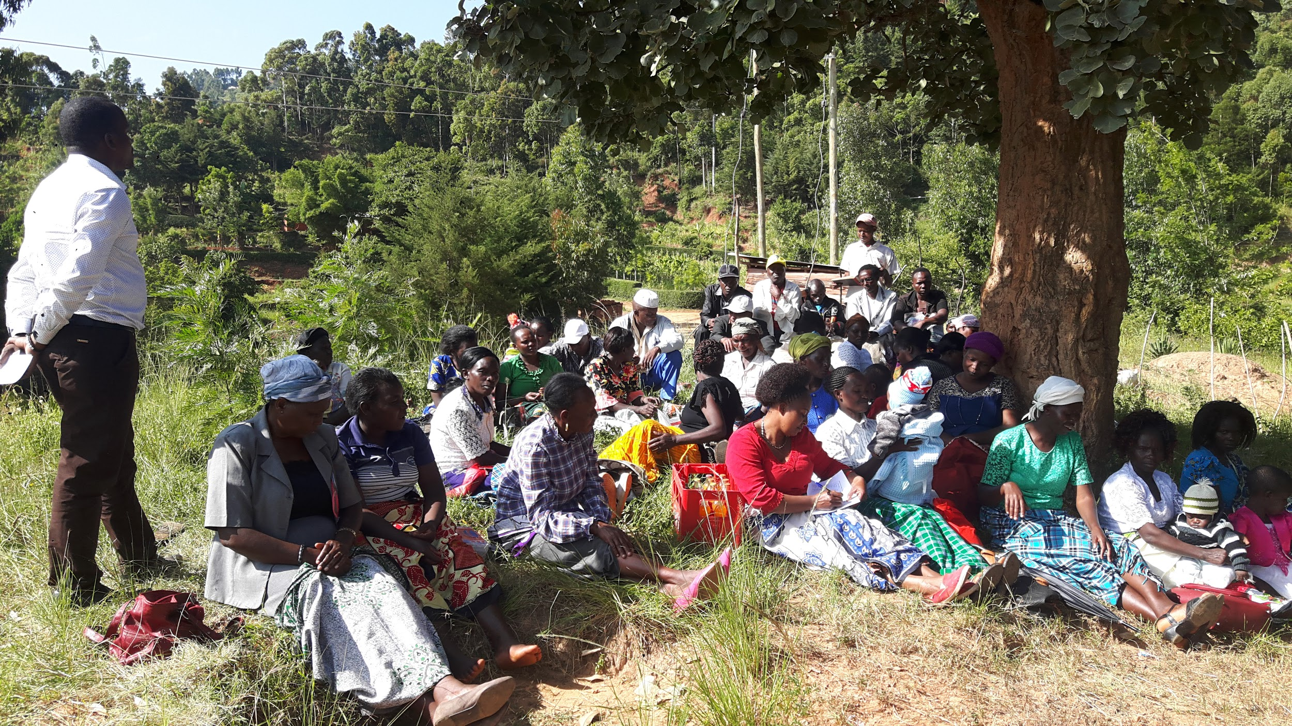
Dr. Makau SCMOHH TEAMS addressing the challenges the Mbuini CHVs raised

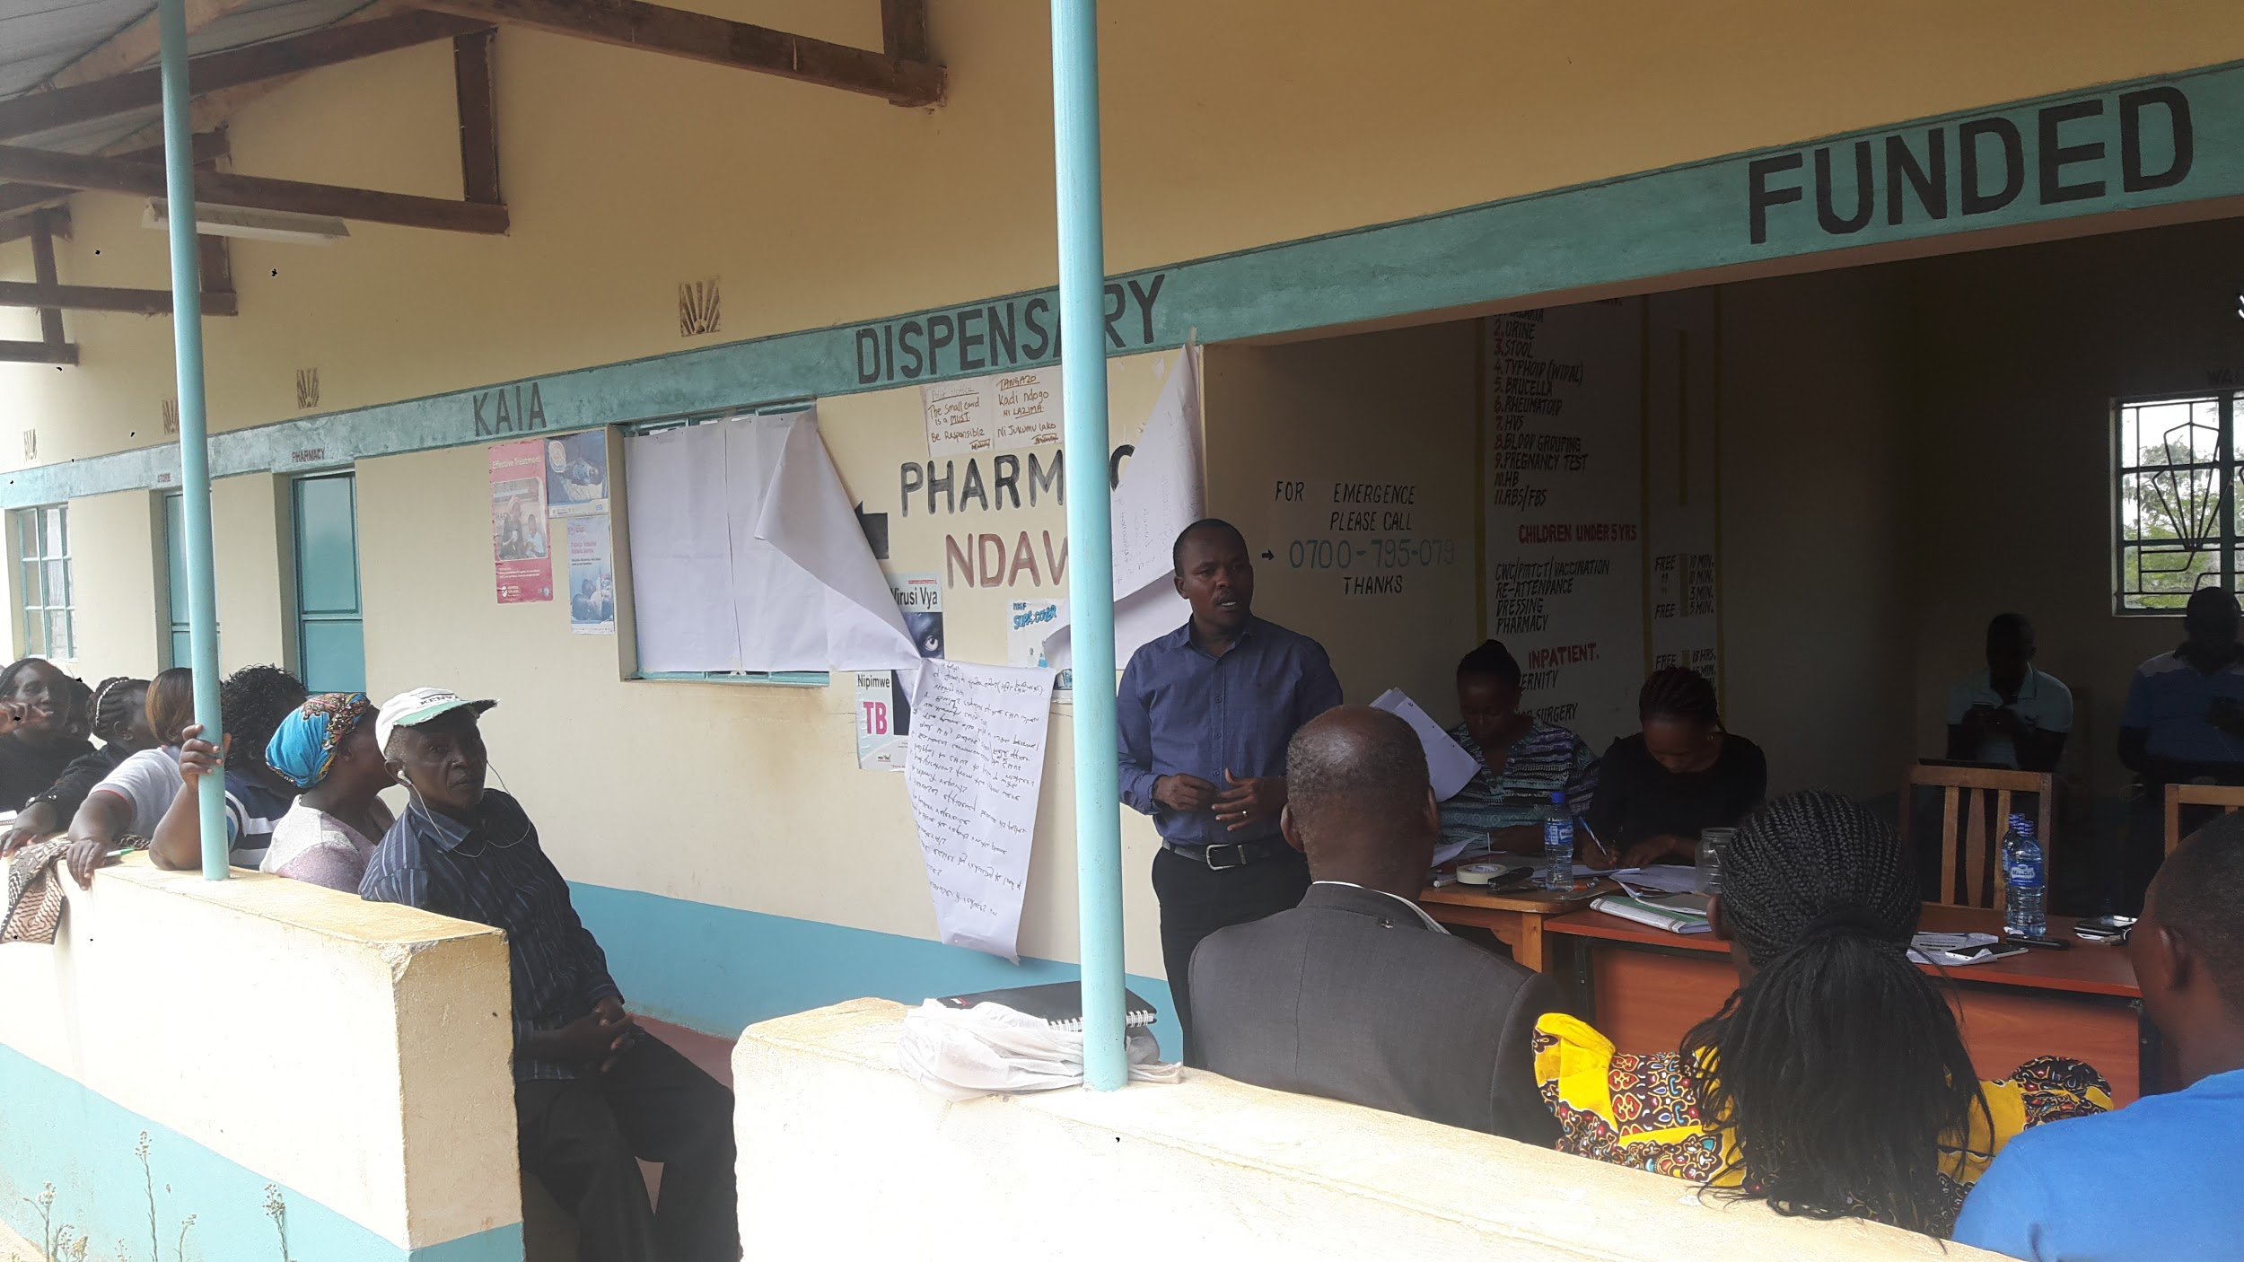
Dr. Makau SCMOHH TEAMS addressing the challenges the Kaia CHVs raised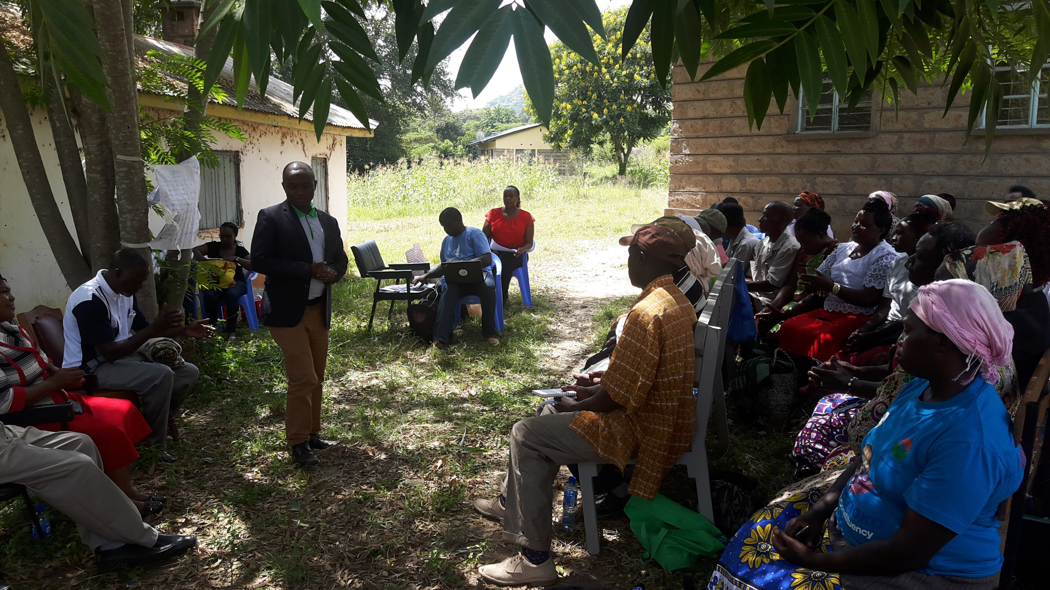
Dr. Ndolo: County Director for Health talking to the Kilala CHVs

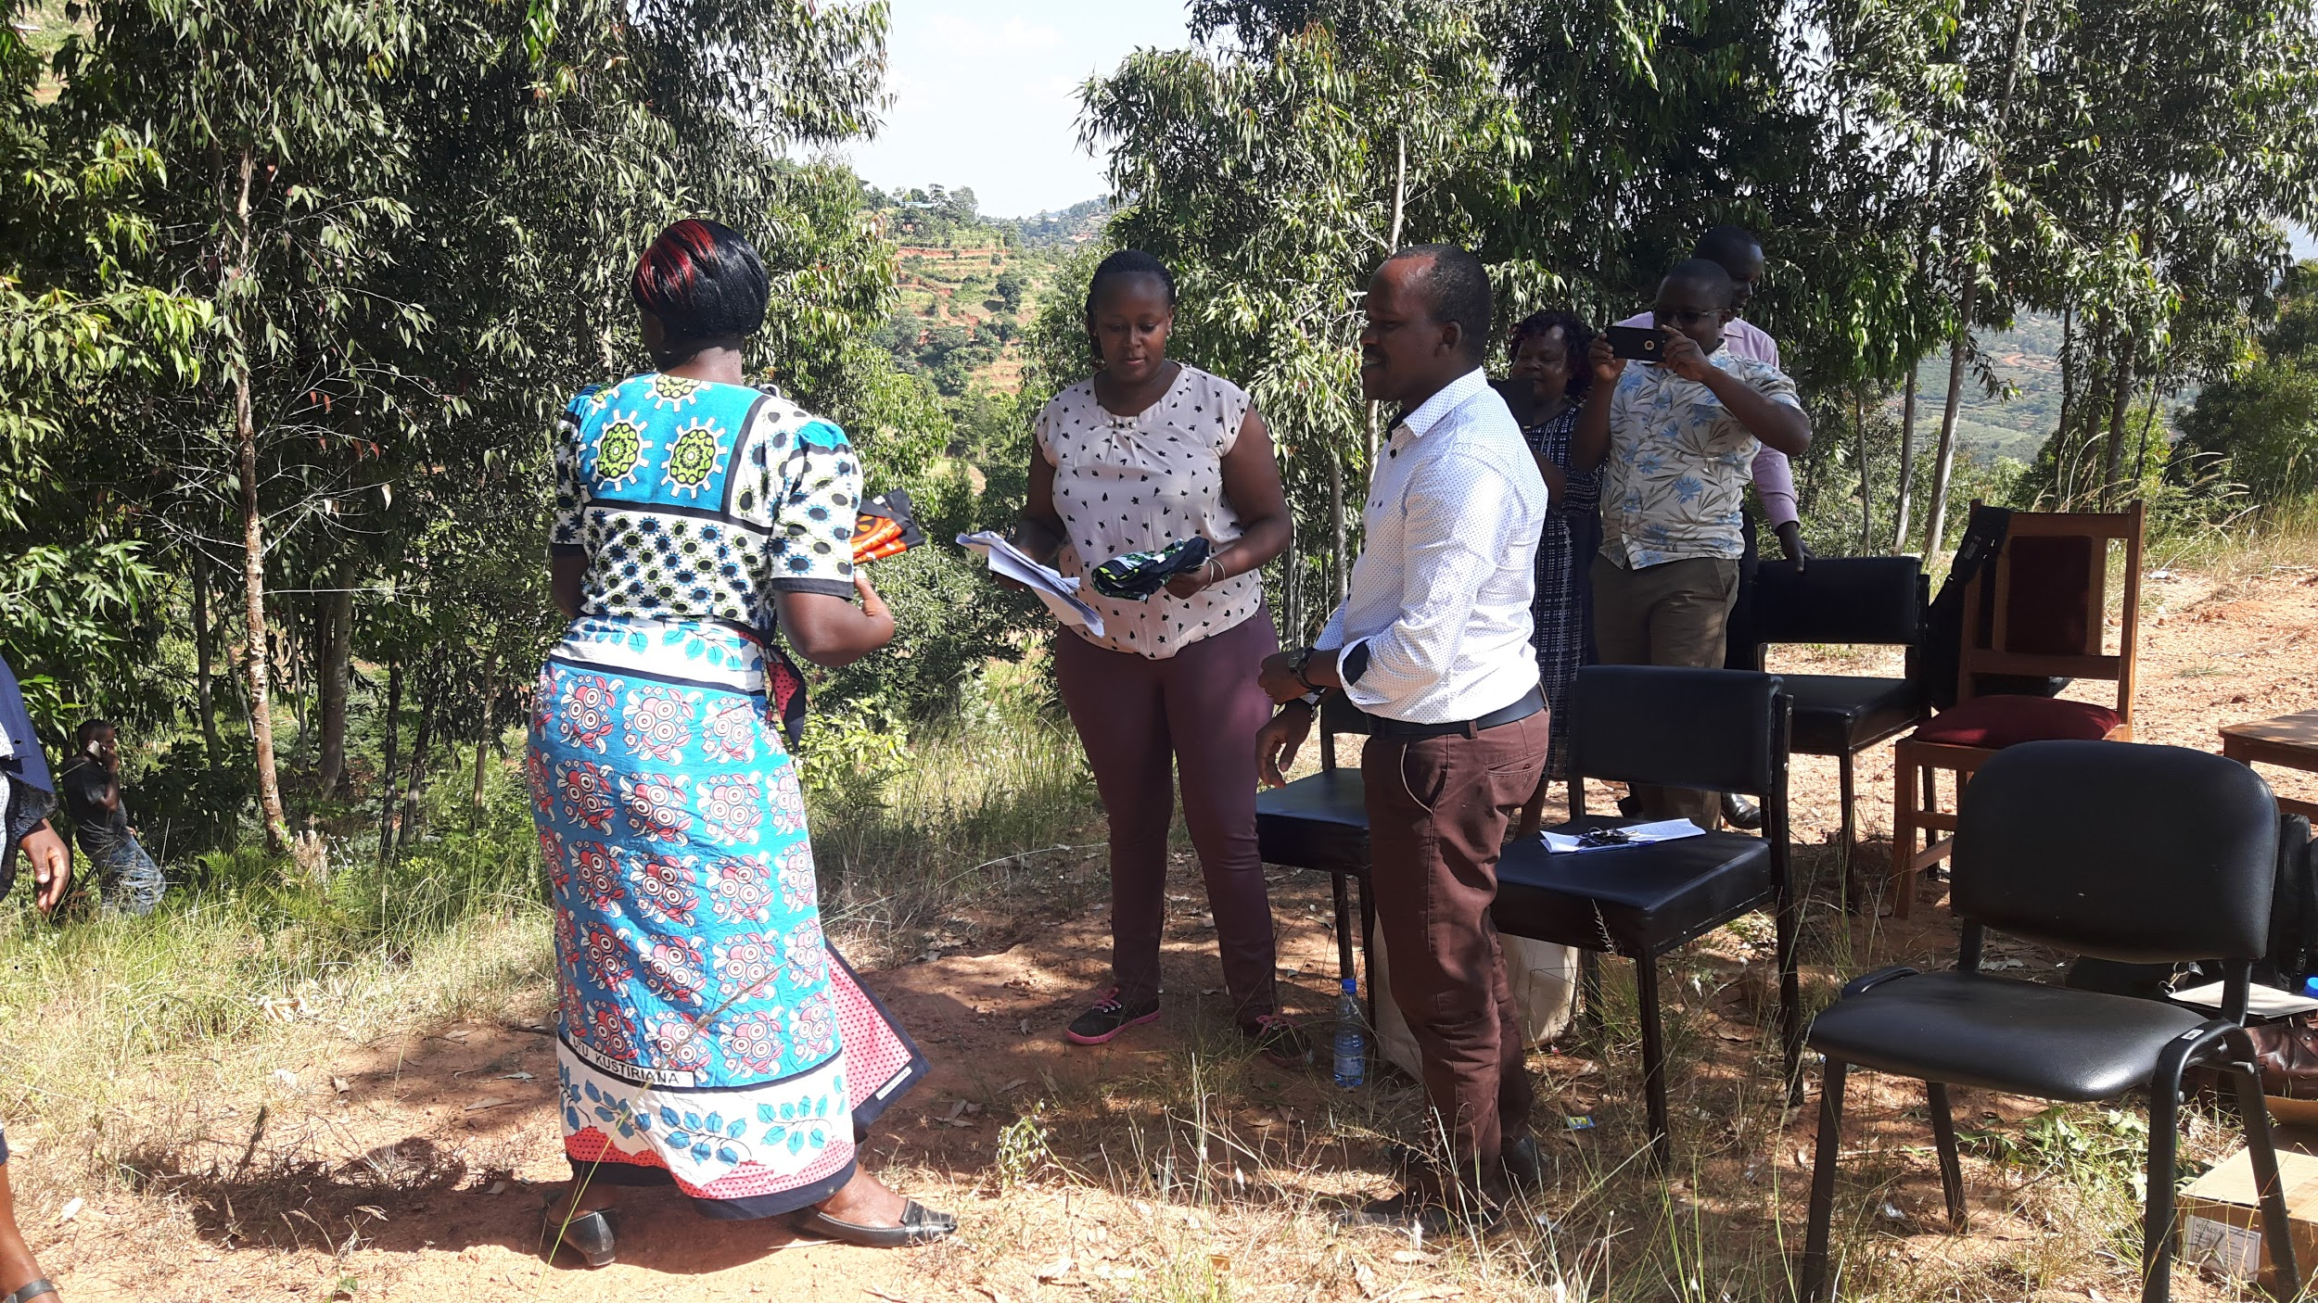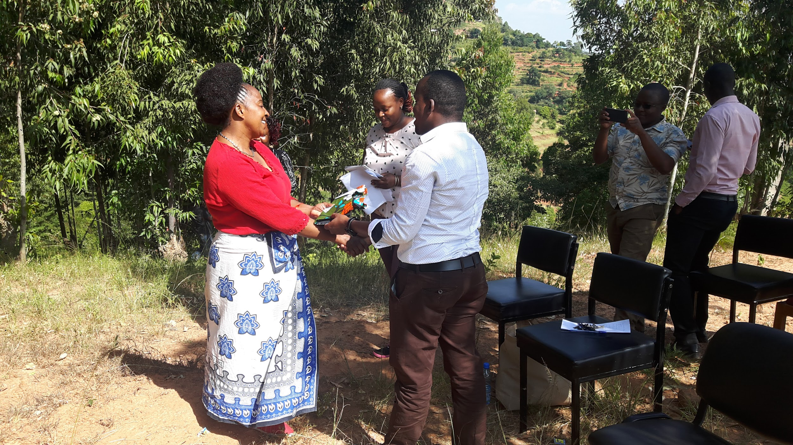

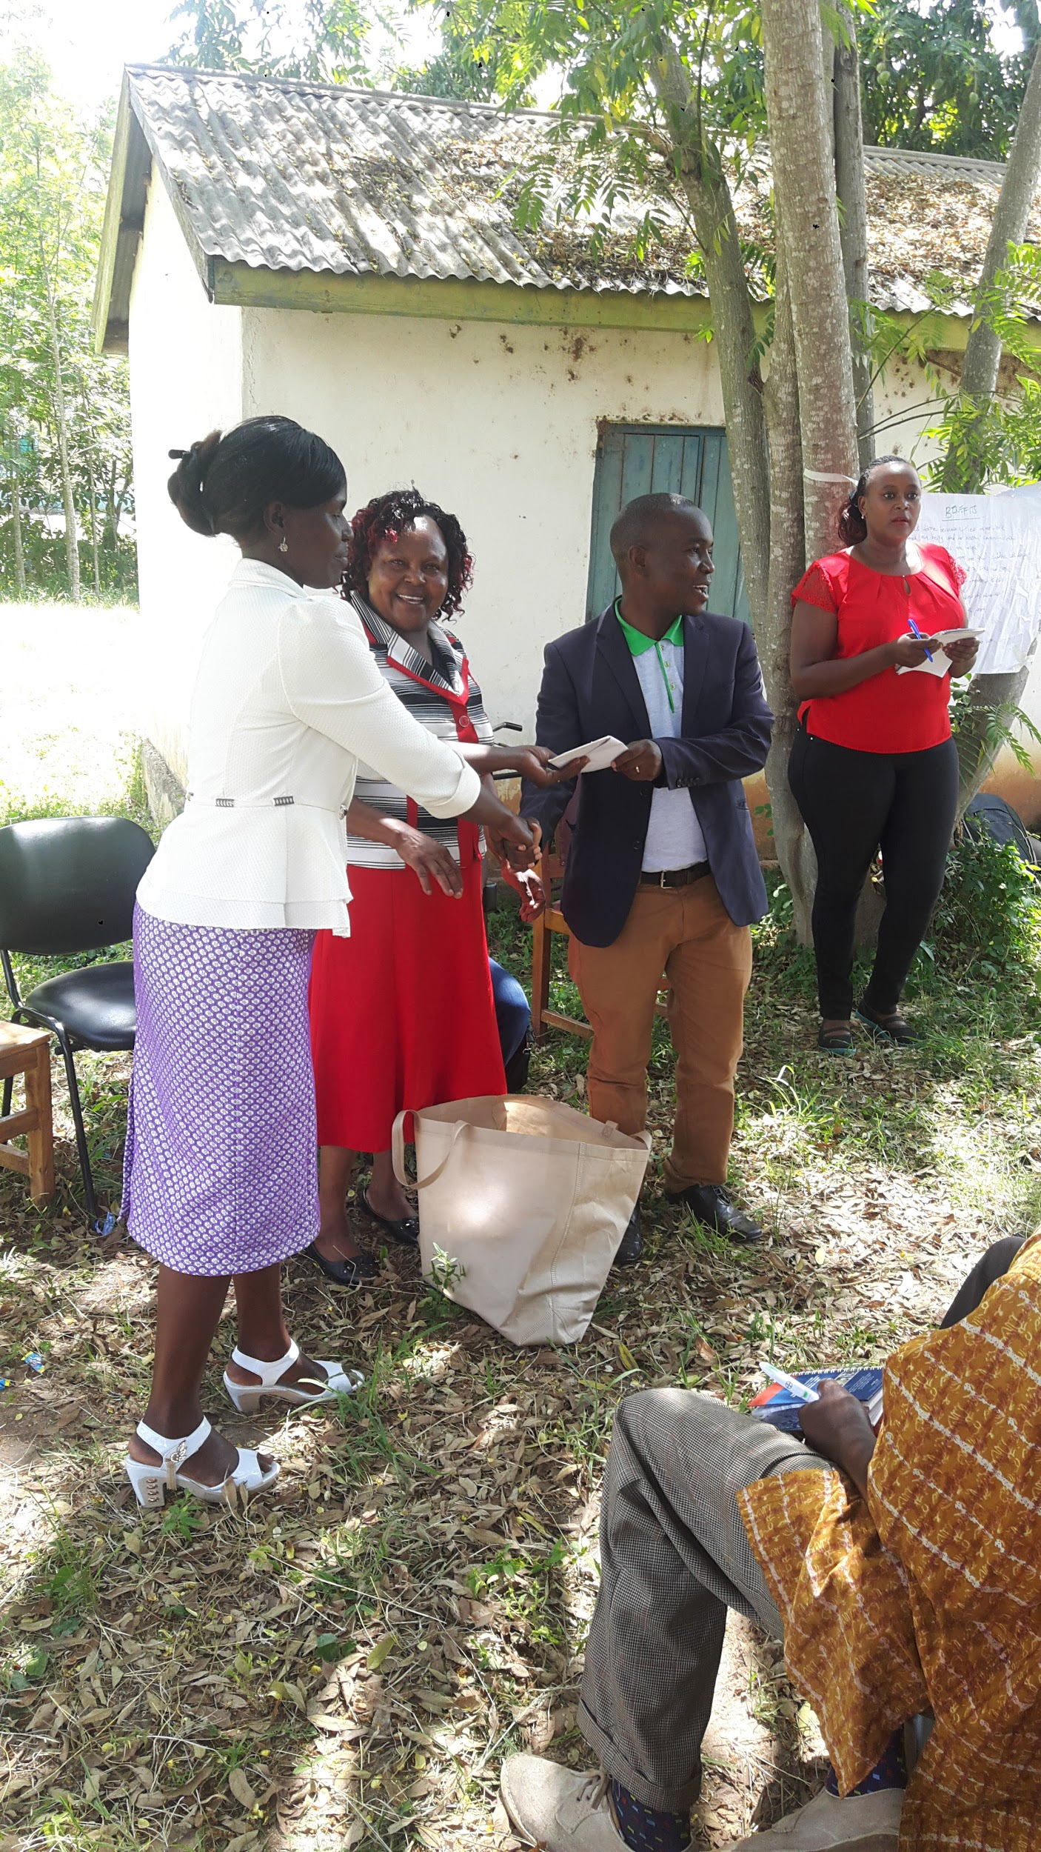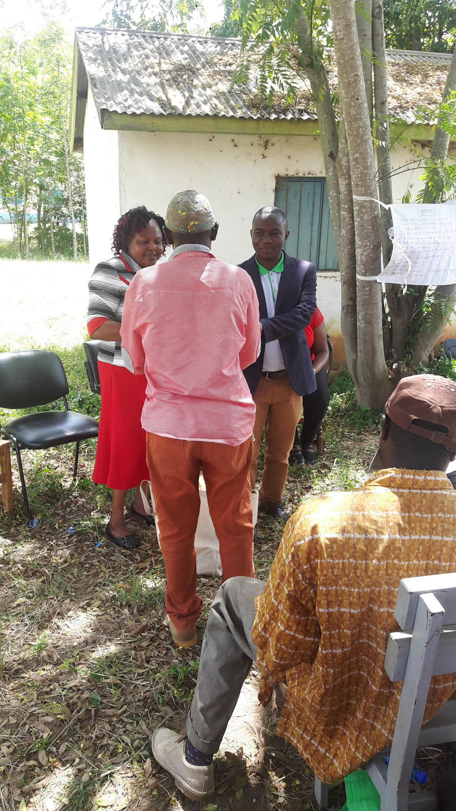

Best performing CHVs getting gifts

Reported by Christine Were 14th February 2018

